# **PART 1 - Game Playing in Python**

**Problem statement**

Simulation of chess with the given sample smaller **3 X 3** cells game board. A player with any piece standing where its opponent sacrifices all the piece is a win for the first player.

**Constraints**

* **Soldier/Pawn (S)** can move only one straight step ahead. Only if opponent coins are available, it can move in diagonally one step forward to attack the opponent coin.
* **Horses/Knight(H)** can move either forward/backward in L–shaped strides covering exactly 3 tiles. It is the only piece that can jump over other coins.
* **Elephant/Rook (E)** can move either vertically or horizontally up to maximum length of the board.

**Existing state of the board:**



Pieces / Coins given : Knight (**K**), Pawn (**P**) and Rook (**R**) for *White* and Pawn (**P**), Knight (**K**) for *Black*.

**Our Approach for solution** **:**

Solution for the given problem statement can be implemented using **Minimax algorithm** with a static evaluation function that calculates the board value based on remaining pieces.

**Heuristic Evaluation Function** : Method of quantifying how “good” a game state for a given player. This approach may not result perfect results.

**Minimax Algorithm** : Given process to select the move for a coin among all possible moves for a game state.

Values taken for each coin :

|  |  |  |
| --- | --- | --- |
| Coin/Piece | Color | Value |
| Pawn (P) | White | 10 |
| Pawn (P) | Black | -10 |
| Knight (K) | White | 30 |
| Knight (K) | Black | -30 |
| Rook (R) | White | 50 |

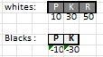

**Static evaluation ( heuristic ) method and movements of coins:**

Given state is considered as Root node to construct a tree with all possible moves for each piece i.e. Rook, Knight and Pawn for White / Black.

Model calculation for given state of pieces :

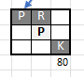**White score :** Pawn 10 + Rook 50 + Knight 30 = 90

**Blacks score :** Pawn -10 = -10

**Static evaluation value for the current node :** 90-10 = 80

A section of the tree is given below :

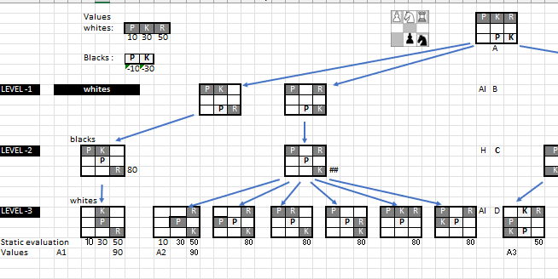

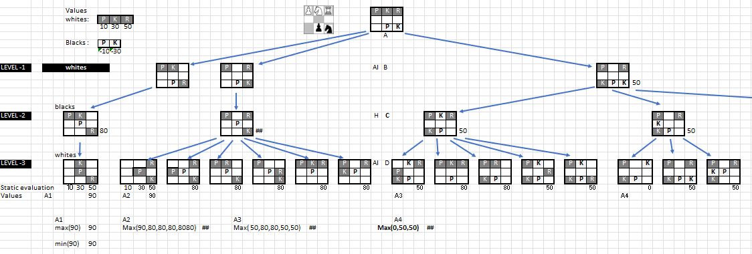

( *Pls note : Since the tree is very large, a part of the same is taken for illustration* )

**Evaluation at root node**: Sum of Whites + Sum of Blacks ( whites are given positive values where as blacks are taken negative values ).

**Code for static evaluation function :**

The static evaluation of the board state looks at all the available coins of a color and computes the total sum. The evaluation function keeps the maximizing color (color chosen by the computer) as positive and the minimizing function as negative to calculate the board score.

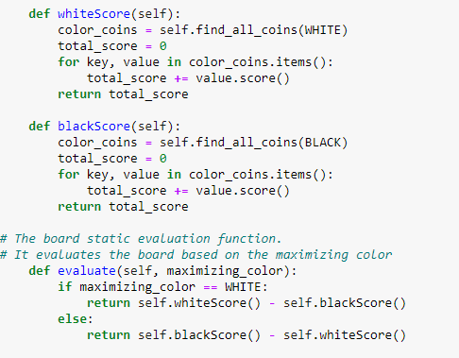

The static evaluation function is chosen to represent the board with respect to the capability of the pieces. In chess game, the Rook is considered to be more powerful than the Knight and Pawn is the weakest piece. The points of **50**, **30** and **10** are chosen to give adequate gap between the coins.

Eg: if one side has a Knight and a Pawn and the other side has a Rook, the side having Rook is considered to be in a stronger position. To accommodate this, points are given with enough interval.

The evaluation function considers the “*maximixing color*” while evaluating the board. This is required as operator can choose his color. As the computer color will always be the “*maximizing color”*, this information is passed as an an argument to the function.

**Minimax Algorithm :**

Below tree structure depicts Minimax algorithm for given case.

For example, we have considered the maximum from Level 3 from all the values taken from white moves. The maximum for the respective levels to be taken for Level-2 nodes. The next move is to take minimum of all the Level-2 nodes would be taken to Level-1 nodes from the respective child nodes. Again maximum of all level-1 nodes tobe taken to the Root node.

Part of the tree structure is given below for minimax movements for three levels :

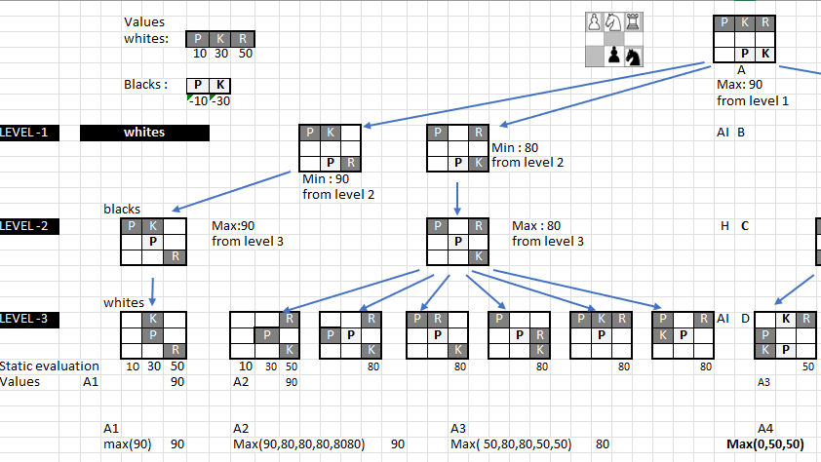

The code implementation applies logic same as the decision tree represented above to identify the next best move.

While analyzing the possible movements, it creates a copy of the existing board state and resets the original board state after evaluating the moves.

Minimax function is called recursively for each possible tree depth evaluating all possible board states. Since the board depth is only three, alpha-beta pruning is not applied in the Minimax implementation.

**Code for Minimax algorithm :**

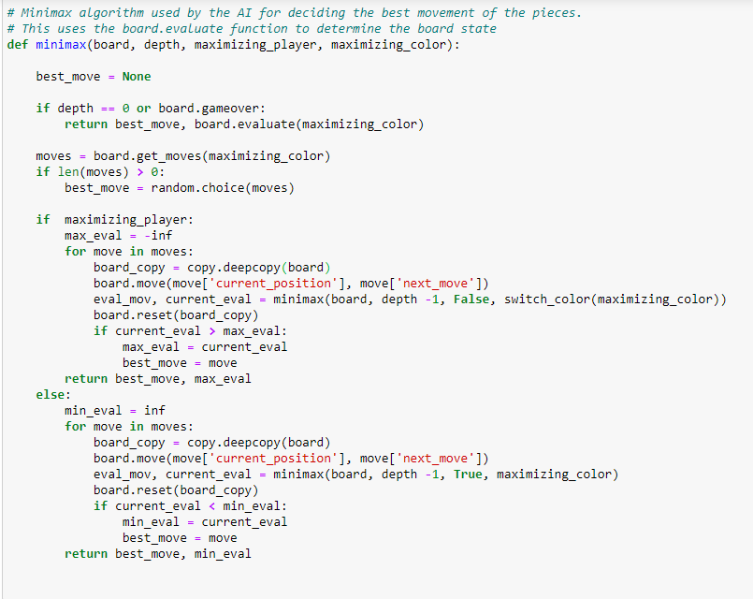

**Data Structure for Chess Implementation :**

The main data structures used for the chess game are:

1. **Game:**

The Game class define the current state of a game. This holds the instance of gameboard, the chosen colors of operator and computer and also indicates whether game is over or not. Some of the important functions are:

* 1. *start*
  2. *run_game*
  3. *is_computer_turn*
  4. *make_next_move*
  5. *is_legal*
  6. *ask_and_move*
  7. *ask_for_input*
  8. *set_board*

1. **Board:**

The Board class represents a 3 x 3 chessboard and its associated functions. Some of the important functions of the board are:

1. *evaluate*
2. *find_coins*
3. *print_board*
4. *move*
5. *gameStatus*
6. *is_playable*
7. *add_piece*
8. *next_turn*
9. *can_move*
10. *get_moves*
11. *find_all_coins*
12. **Piece:**

Piece class is the parent class of all the individual pieces of the chess board. Piece class defines the common functions inherited by all the individual pieces. Piece instance has attribute value to indicate its color and linked image representation. Important functions are:

1. *next_location*
2. *is_valid*
3. *get_color*
4. **Classes for individual pieces (Knight, Rook, Pawn):**

Knight, Rook and Pawan are subclasses of Piece class and represents various types of pieces available in the chess board. Important functions are:

1. *score*
2. *availableMoves*

**Dynamic Input :**

1. For initializing the game, the operator has to choose a color between white and black. The operator color is taken using an “input box” when the game starts. The computer chooses the other color. The computer color will be considered as the maximizing color for board evaluation.

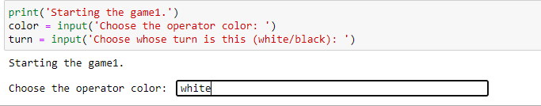

1. The starter color for initiating the game is another input for the application. If operator’s color is chosen as the start color, the program waits for the movement instructions. Otherwise, computer will make the first movement.

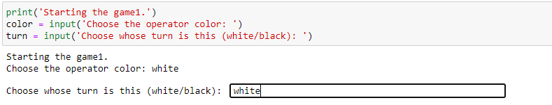

1. In the above example, we have selected “*white*” as the operator color and “*white*” as the starter color. The progam will wait for operator instruction to make the first move.

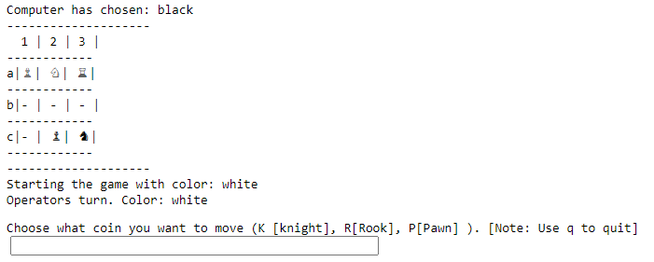

1. After the first move is provided by the operator, the computer decides the next move based on Minimax algorithm and makes the move. It waits for further instruction from the operator to continue the game.

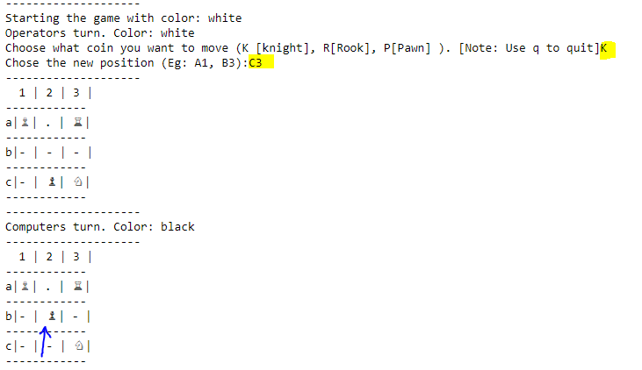

1. The sequence of accepting user’s input and computer’s action continues till the game ends with a clear winner or a stalemate. The status of the gameboard is printed on the screen.

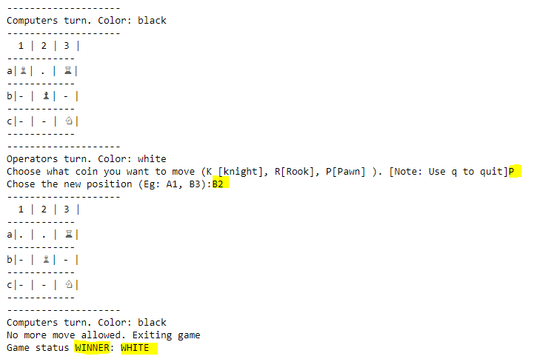

**Screenshot of program execution :**

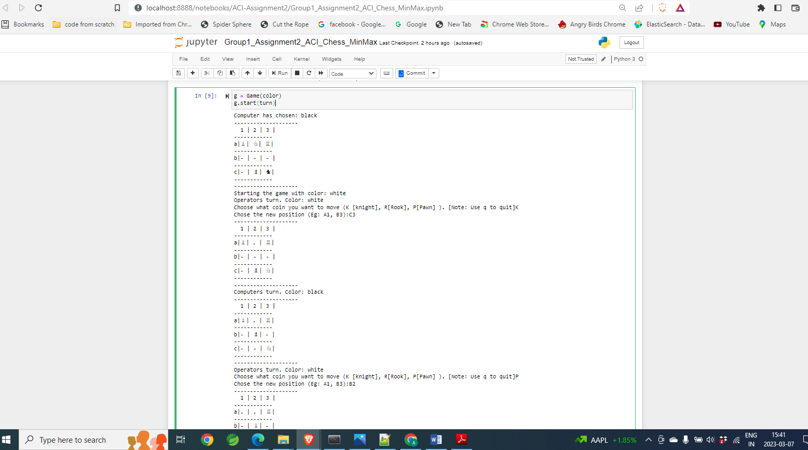

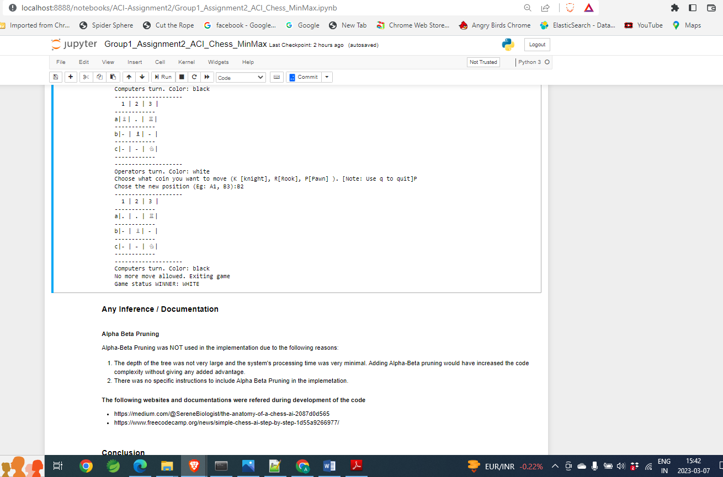

**Summary :**

The minimax algorithm with the evaluation function provides reasonably good approach to identify the next best move. In the given problem statement of 3x3 chess board, number of branches and depth are limited and can be managed by normal computer systems. If the depth and branches are higher, algorithm can be improved by applying alpha-beta pruning.

However for full chess implementation, this algorithm may be too slow. Advanced AI algorithms are used for such full chess game play implementations.

**PART 2. Logic Design and Inferencing in Prolog**

**Problem Statement :**

A decision tree (given) is derived from the raisin classification dataset. The problem statement is to derive if-then rules from this tree and code them as Prolog rules. The Prolog code must take the attribute values as input and classify the raisin type.

**Attribute Information :**

The following are the attributes used in the dataset:

1. **Area**: The number of pixels within the boundaries of the raisin.
2. **Perimeter**: Measures the environment by calculating the distance between the boundaries of the raisin and the pixels around it.
3. **MajorAxisLength**: The length of the main axis, which is the longest line that can be drawn on the raisin.
4. **MinorAxisLength**: The length of the small axis, which is the shortest line that can be drawn on the raisin.
5. **Eccentricity**: A measure of the eccentricity of the ellipse, which has the same moments as raisins.
6. **ConvexArea**: The number of pixels of the smallest convex shell of the region formed by the raisin.
7. **Extent**: The ratio of the region formed by the raisin to the total pixels in the bounding box.
8. **Class**: The class of the raisin, either 'Kecimen' or 'Besni'.

**Decision Tree :**

The given decision tree (generated from the raisin dataset) is as follows:

MajorAxisLength <= 422.279133

| Perimeter <= 1006.375: Kecimen (287.0/24.0)

| Perimeter > 1006.375

| | Extent <= 0.7476

| | | Perimeter <= 1122.831

| | | | Area <= 62835

| | | | | Extent <= 0.701678

| | | | | | Extent <= 0.666255: Besni (4.0)

| | | | | | Extent > 0.666255: Kecimen (4.0)

| | | | | Extent > 0.701678: Besni (6.0)

| | | | Area > 62835: Kecimen (124.0/24.0)

| | | Perimeter > 1122.831

| | | | Extent <= 0.671309: Besni (7.0)

| | | | Extent > 0.671309

| | | | | Eccentricity <= 0.75951: Besni (22.0/7.0)

| | | | | Eccentricity > 0.75951: Kecimen (9.0/1.0)

| | Extent > 0.7476: Kecimen (27.0)

MajorAxisLength > 422.279133: Besni (410.0/41.0)

**Raisin Classifier using Decision Tree in Prolog :**

The program is a simple implementation of a decision tree classifier for classifying raisins into two categories - ***'Kecimen' and 'Besni'*.** The decision tree was generated using a dataset containing various attributes of raisins, such as ***Area, Perimeter, MajorAxisLength, MinorAxisLength, Eccentricity, ConvexArea, and Extent.***

**Graphical Representation of Decision Tree**

***<= 422.279133***

***> 422.279133***

Besni

***<= 1006.375 > 1006.375***

Kecimen

***> 0.7476***

***<= 0.7476***

Kecimen

***<= 1122.831 > 1122.831***

***<= 62835***

***> 62835 <= 0.671309 > 0.671309***

Besni

Kecimen

***<= 0.701678***

***> 0.701678***

***<= 0.75951 > 0.75951***

Kecimen

Besni

Besni

***<= 0.666255***

* ***0.666255***

Kecimen

Besni

**Code for the Raisin Classifier in Prolog:**

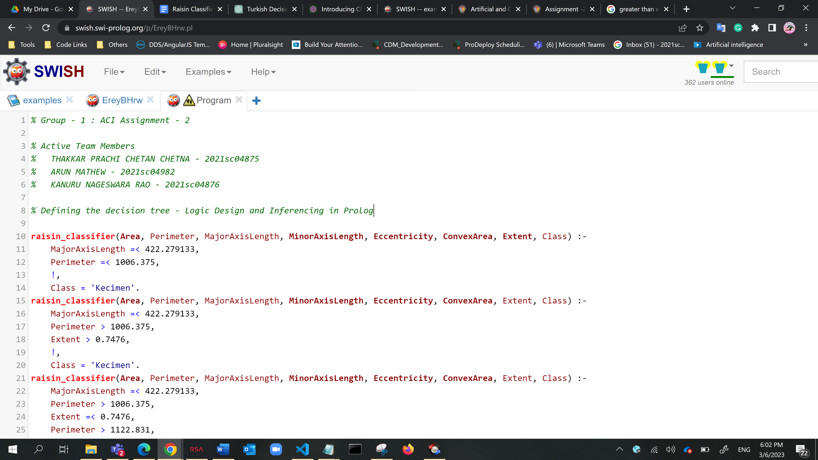

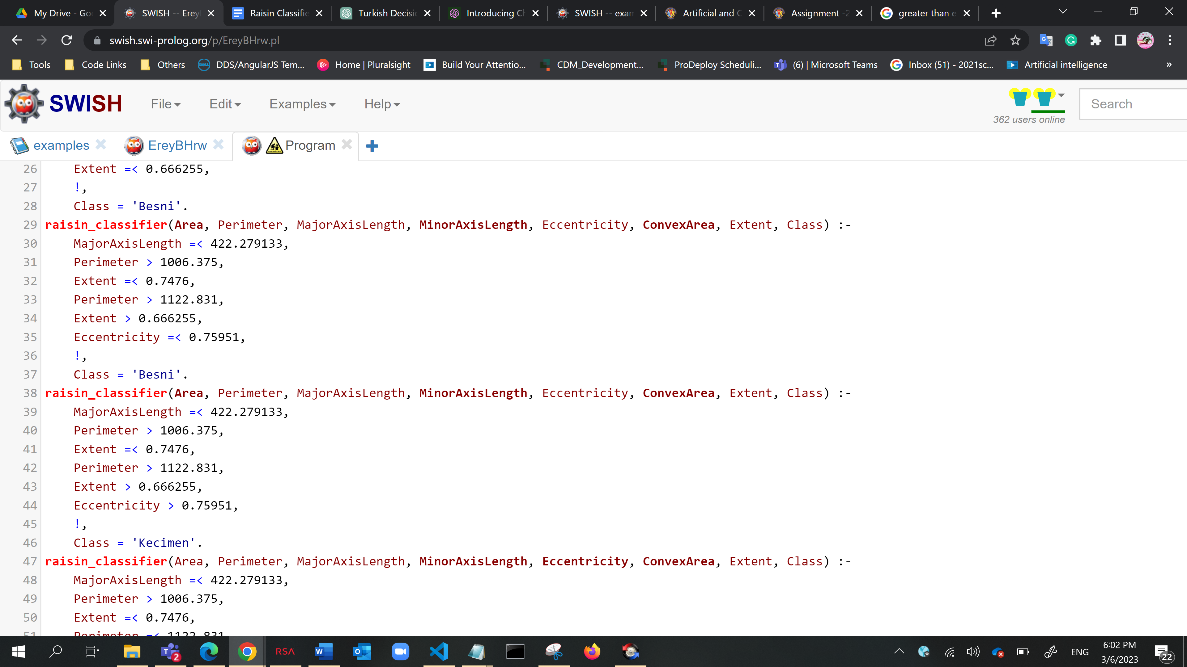

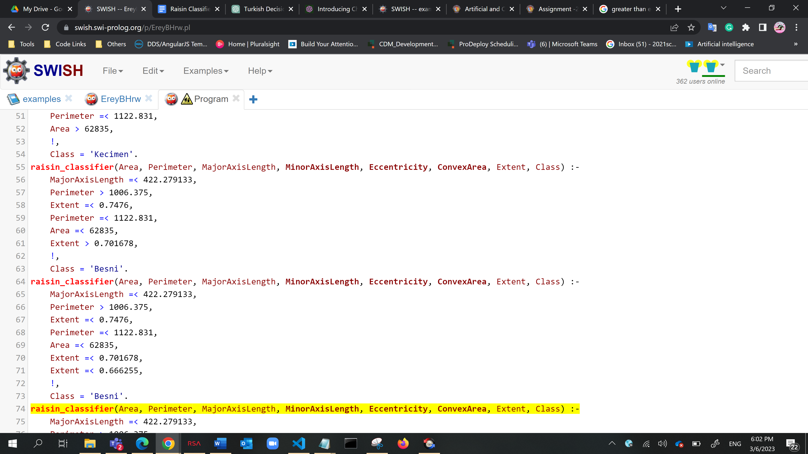

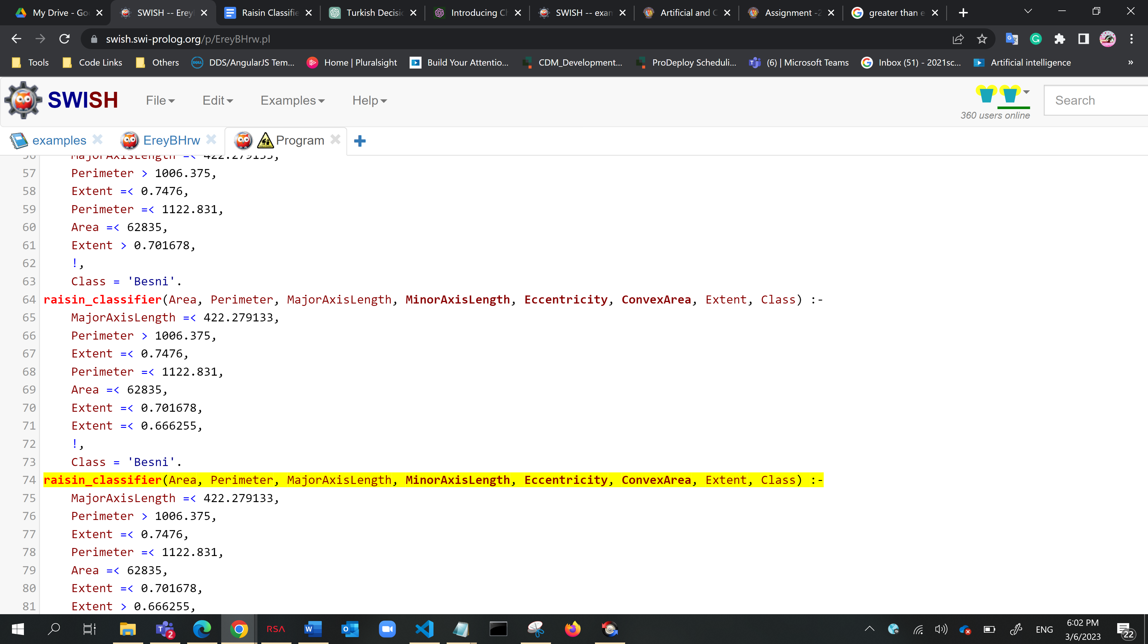

**Queries**

**% Sample queries**

**?-** *raisin_classifier*(1000, 1200, 450, 350, 0.8, 800, 0.6, Class)

**Class =** ‘Besni’

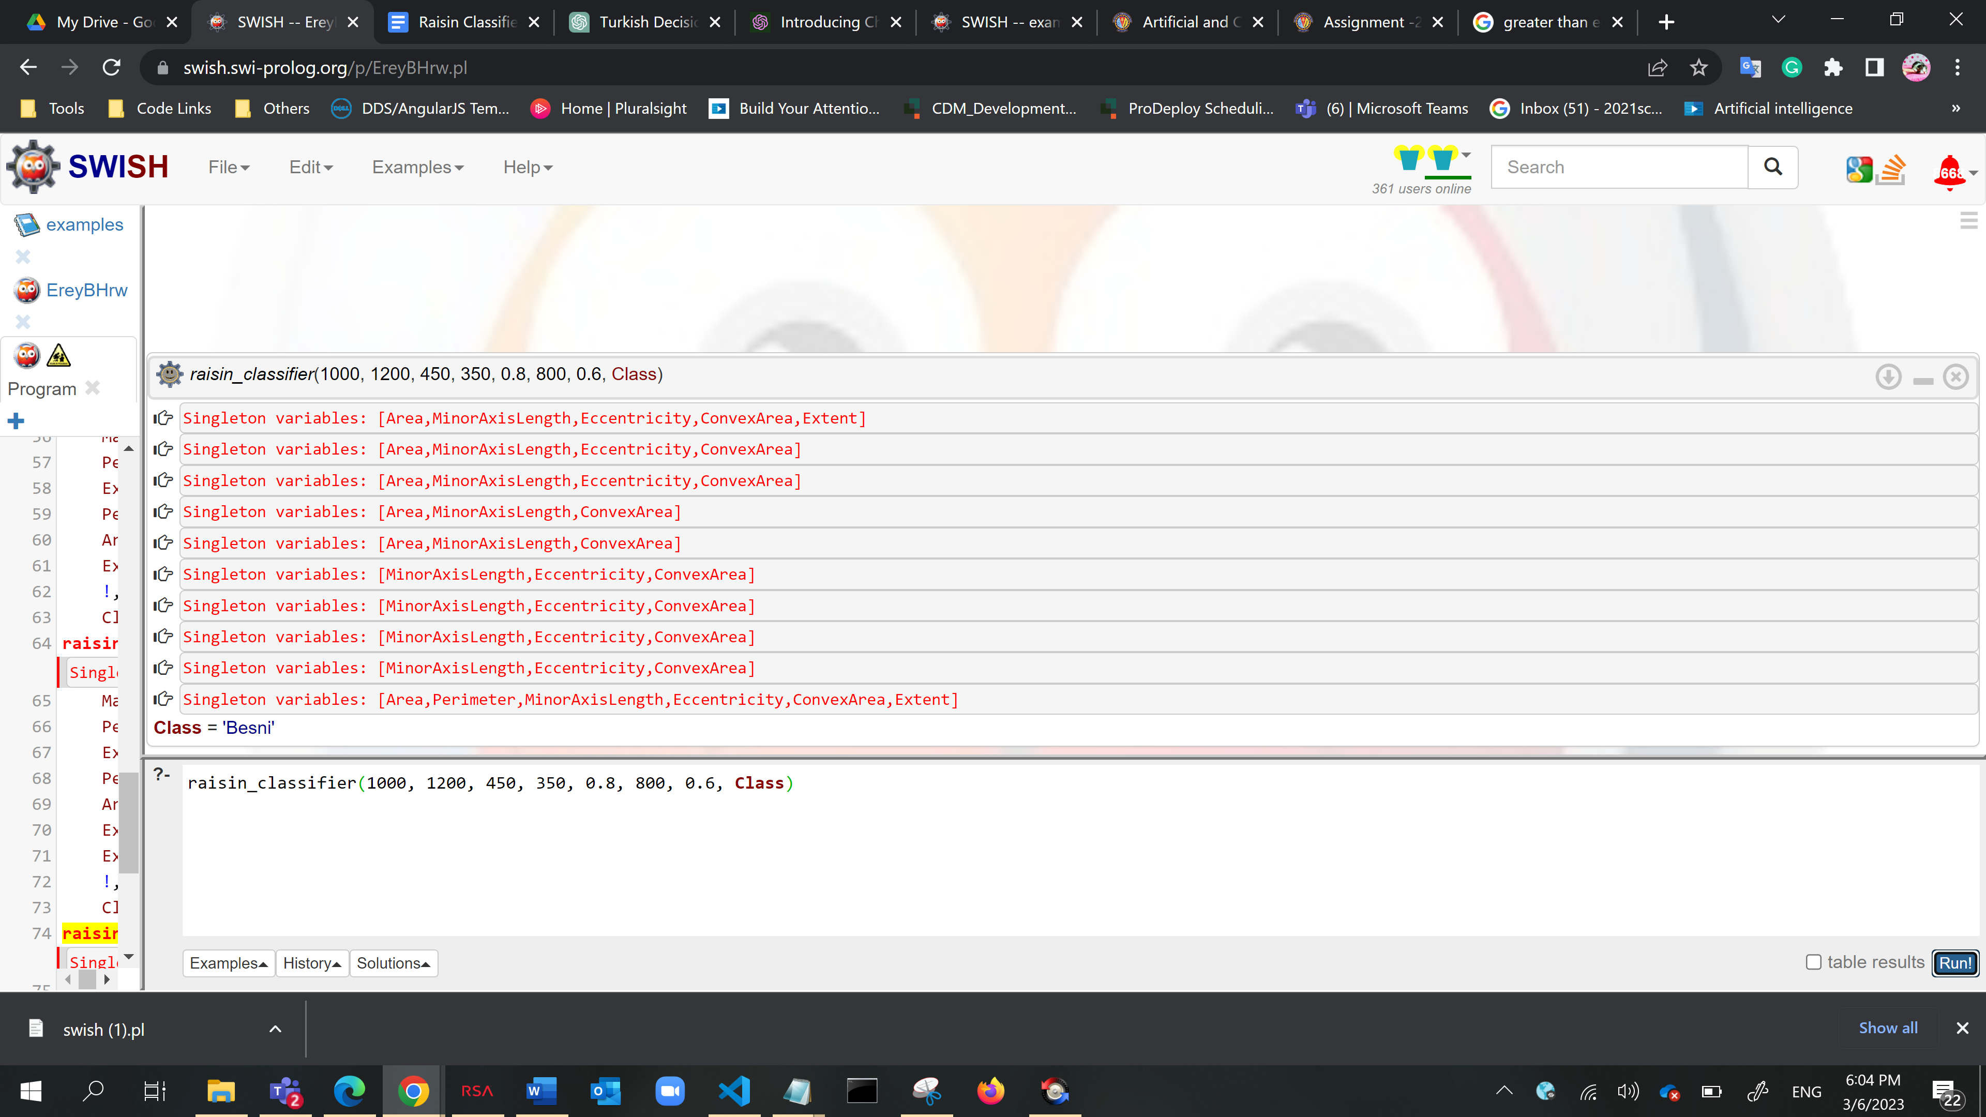

**?-** *raisin_classifier(330, 149, 36.270, 23.851, 0.719, 340, 0.442, Class)*

**Class =** ‘Kecimen’

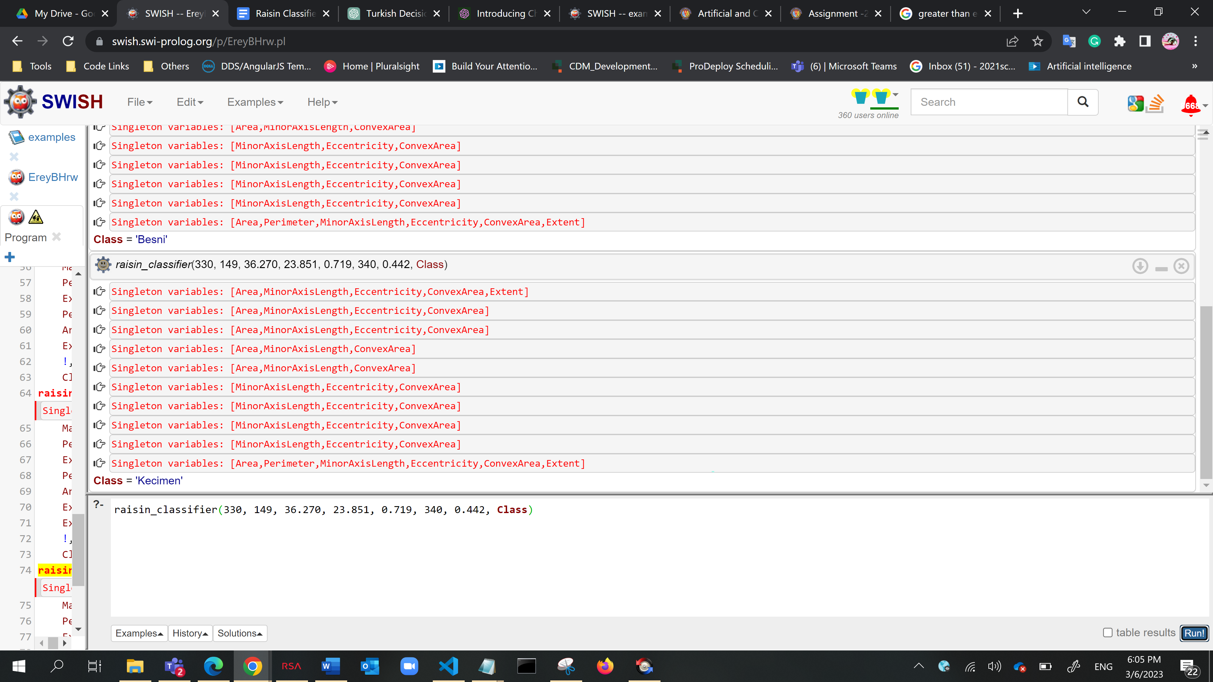

**?-** *raisin_classifier(330, 149, 36.270, 23.851, 0.719, 340, 0.442, Class = 'Besni')*.

**false**

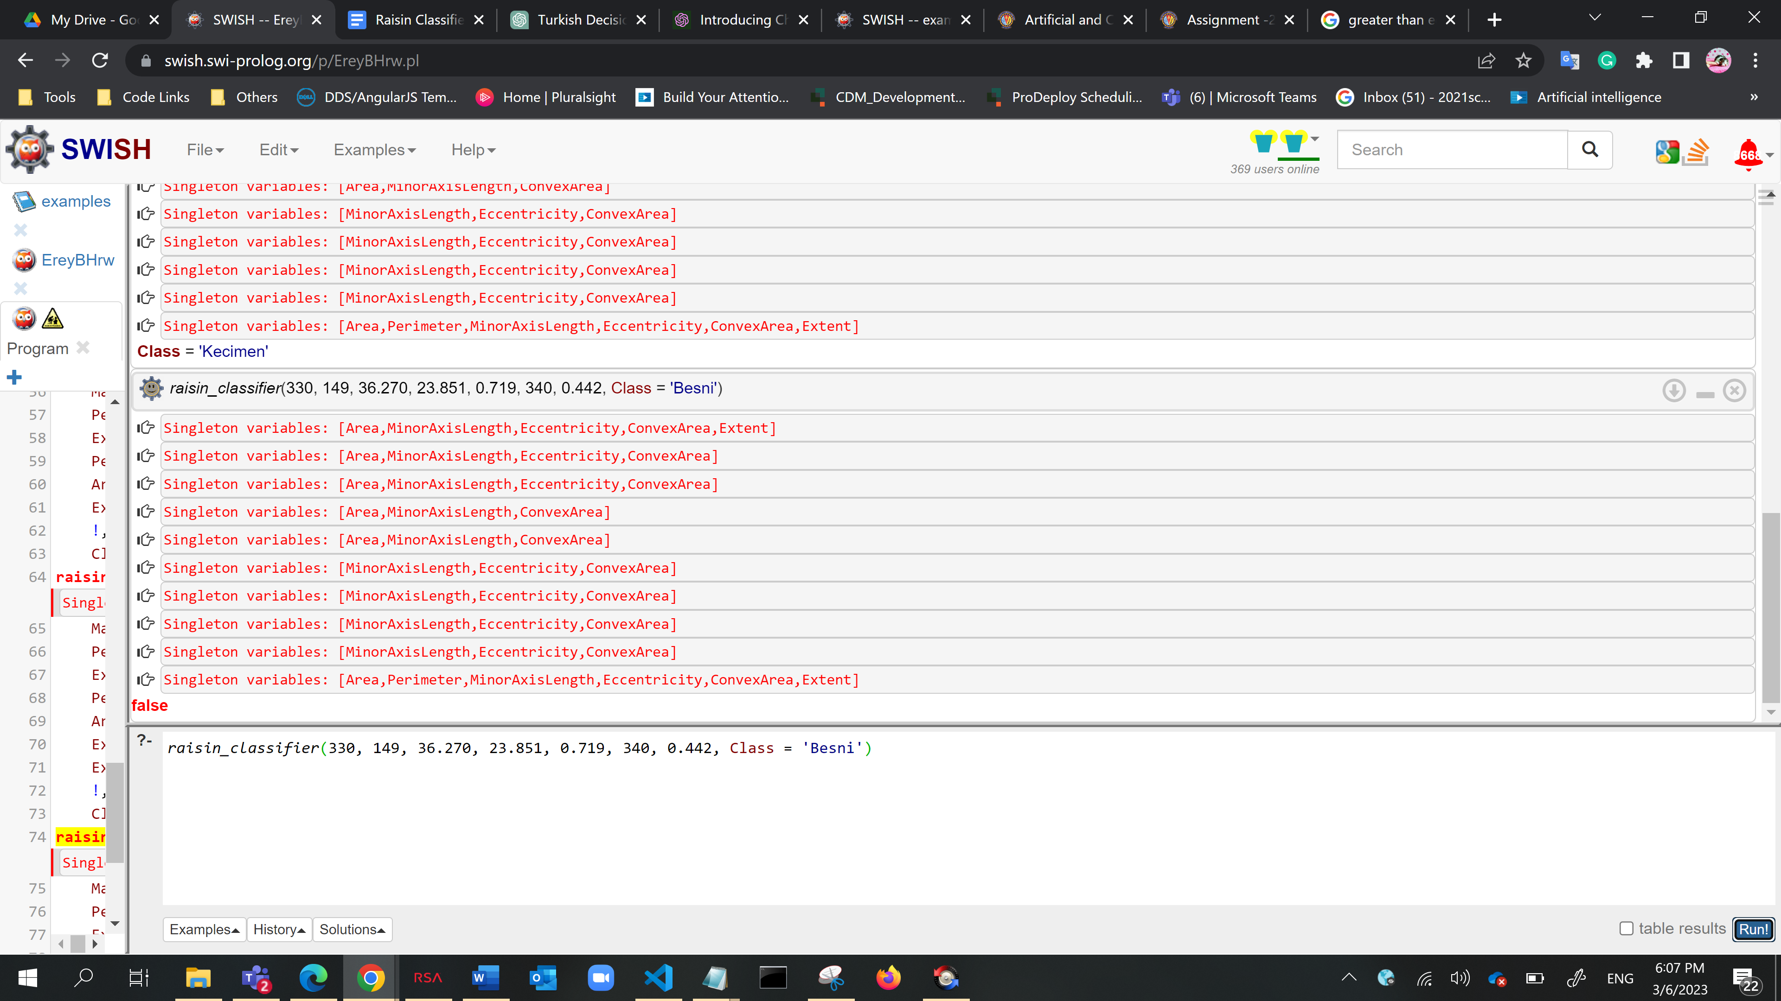

**Summary :**

* **Predicates** - raisin_classifier
* **Variables** - Area, Perimeter, MajorAxisLength, MinorAxisLength, Eccentricity, ConvexArea, Extent, Class
* **No. of Clauses** - 10
* **Data Structure** – Lists

In this code, ***raisin_classifier*** is the main predicate that takes in the attributes of the raisin as input and classifies it as either ***'Kecimen' or 'Besni'***. It does this by traversing the decision tree using the input attributes and returning the corresponding class label.

A Prolog program can do useful things with a data structure even when that structure is partially unknown. With ease of representing knowledge, natural support of non-determinism, pattern-matching & meta-programming, the decision trees can be made more efficient by increasing the size of the knowledge base.